Please read the guidelines carefully and follow them –

ISKCON Contact Person - SMT. SRIVANI (Ph.no. 9440486792)

**Guidelines for Conducting Intra & Inter College Elocution Competition**

1. Colleges should announce the date and venue for the competition at least four days in advance on their campus, preferably they can take a print-out of an A3 size poster and affix it on their notice boards.

1. All participants must register themselves at www.iskconkukatpally.in (QR Code given below) before the competition date. Non-registered participants will not be allowed to progress to the next round. Participants who have not registered with us will not be awarded certificates or any awards.

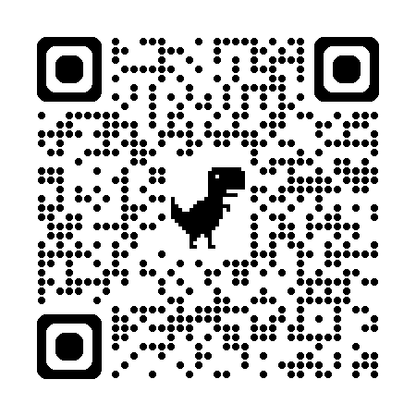

1. Any number of students can participate in the intra-college round of the competition. However, only the toppers will be eligible to progress to the next round of the competition.
2. The Speakers can opt for any language either in Telugu/English/Hindi
3. There is no registration fee to participate.
4. It is recommended that the elocution competition be conducted in the presence of fellow students for better awareness and a long-lasting impact.
5. The College should allot the numbers to all the intending speakers instead of calling them by their names while participating in the competition. They should wear a number badge during the Competition. However, the Principals should send the Actual names and other details of the Participating Students along with the numbers assigned to the Students for the Competition to ISKCON.
6. A Participant must speak for a minimum of 4 minutes and a maximum of 5 minutes.
7. The College Management is requested to Video record each speaker's Talk. They Should use 2 Video Cameras (Front and Back) to ensure no support from the Audience while participating in the Elocution Competition
8. College Management is requested to upload individual videos and the Collective Video as soon as possible using the Google Drive link. Please provide us with the names of all the speakers exactly in the same order as in the video.
9. All the Videos of the Participants will be uploaded to our YouTube channel and will be available for public view. All the videos of the competition will be the property of ISKCON Kukatpally.
10. The Zoom link can be shared by the organizer upon request, and the competition can then be conducted.
11. We are sharing the JPG version of the Banner, please download it – The name of the College, Date, Venue and Time could be inserted in the Banner. However other fields should not be changed.
12. Every College is requested to display the Banner in the Background to improve the authenticity. The banner can be displayed using a technology LCD Projector or as a Printed Flex.
13. Colleges can fill out the Google Form (Link and QR code below) and we can design and send the Poster and Banner - <https://docs.google.com/forms/d/e/1FAIpQLScuAmiNa8dEg3p_CfdaLPxgl06-19QHhTTGxEGDyeN_ABn9jQ/viewform?usp=sf_link>

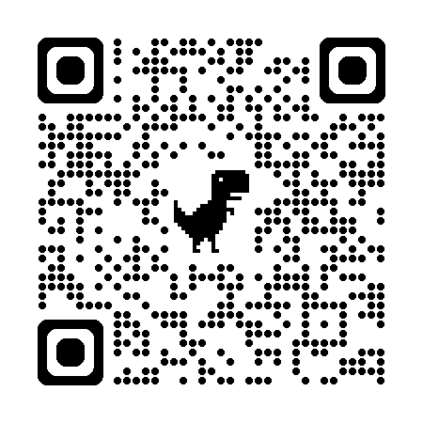

1. All the Participants will be awarded with Participant Certificates duly signed by ISKCON Authorities.
2. Intra-College Competitions - The Panel of Judges has to be appointed by the College itself. ISKCON will not actively participate in it.
3. Every College can recommend the 3 best candidates for Competitions at the District level.
4. The Junior Colleges are requested to update the results of College Level Competitions immediately to us along with Videos and Photographs so that they can be shared with Print and Electronic Media.
5. Each district must have a minimum of 30 colleges that will compete at the district level. If a district has fewer than 30 colleges participating in the district final, it will be combined with another district. The Venue, Date and Time for the District level final will be decided by the Organisers after consultation with the participant colleges. However, once decided that will be the final date.
6. Inter-College Competition -A panel of five judges will be appointed by the ISKCON, including one senior member from ISKCON and four members from different colleges.
7. The Dates of the District level Competition will be announced 5 days in advance. Participants are requested to check their Emails and WhatsApp Mobiles for Communication from time to time.
8. Prizes, Certificates and awards at the district level will be presented after the Competition or at a suitable College Function. VIPs and Dignitaries will be invited.
9. The Inter-District Level Finals will be conducted on the 25th and 26th of October where 5 selected best speakers from each District will be eligible to participate at this level.
10. 25 top Speakers will be shortlisted at this level.
11. The Participants who are eligible to participate at the District level should make their arrangements for travelling to the Venue in the District Chosen by the Organisers. It is requested that a lecturer be accompanied with the Students from the Participating College.
12. On 5th November 2024 the short-listed candidates will speak for up to 7 minutes in the State level Grand Finale.
13. 3 Best Speakers will be awarded with 3 prizes and Certificates. Also, Consolation prizes may be awarded to the students.
14. Those Colleges who comply with all the Guidelines like ensuring all the Participants register themselves, Display posters and banners, Conduct Competitions, Upload Videos in proper order after the Competitions etc will be given a Trophy for their Exemplary Conduct and Support. The Coordinator of the Respective College (Whose number is mentioned in the Banner) will also be given a Certificate.